**Enemy patrol mechanic:**

This tutorial is for adding an enemy and making it patrol between 2 points.

**Step 1: inserting game objects**

Using the previous scenes, create 2 empty objects by right clicking in the hierarchy field and clicking create empty, then create another 2D game object, this can be any shape but to make it easier we will use a square.

Rename these “Waypoint1” and “Waypoint2” and then tag the waypoints as ground so that the player can get jump resets from them. And for the enemy rename it to “Enemy” and give it a tag called “Enemy”

Next, place these two way points where you want your enemy to patrol. This is an A to B linear patrol system so ideally you want them to be on the same elevation.

**Step 2: adding the patrol script**

Next add a new script to the enemy game object and name it “EnemyPatrol”.

This script will be for the enemy object to move between both points at a set speed, insert the following script.

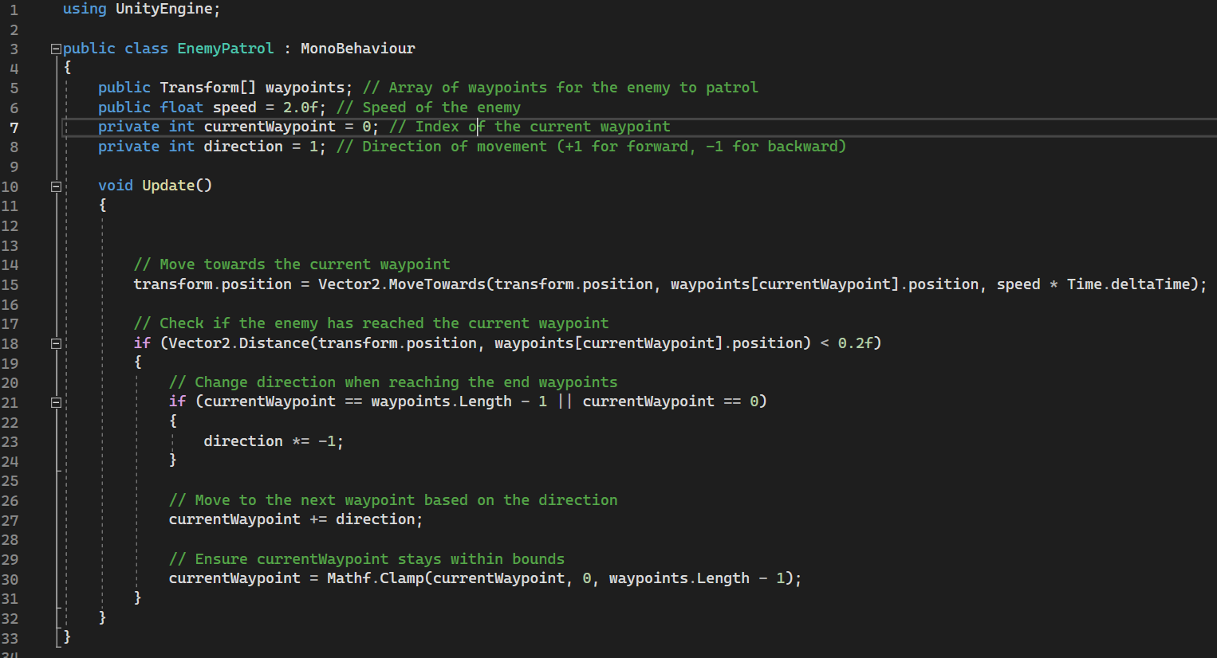

I've written what each line of code does in green, but essentially, this script uses the waypoints as a reference as to where the enemy should transform to, once the enemy reaches the waypoint, it changes direction and heads to the other waypoint. We can see this in the if statements. We also add in

“currentWaypoint = Mathf.Clamp(currentWaypoint, 0, waypoints.Length - 1);”

to stay within the range of the two waypoints to avoid any index out of range errors.

As the speed and waypoints are a public variable, they can be changed in unity which allows us to also assign the waypoints to this script.

**Step 3: assigning waypoints**

The next step is to go to the new drop-down menu and dragging the waypoints from the hierarchy to its respective fields.

Once this is done, play the scene and you should see the enemy move back and forth between the two waypoints.